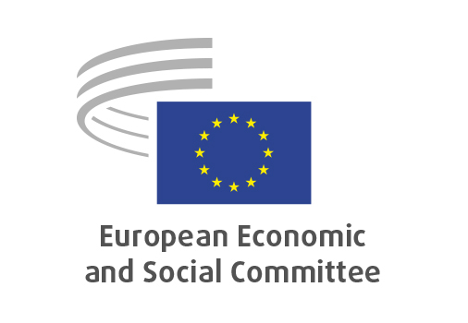

**EN**

**NAT/930**

**Unfair trading practices in B2B relationships in the agricultural and food supply chain**

Brussels, 27th March 2025

**RECORD OF THE PROCEEDINGS**  
European Economic and Social Committee  
  
**Evaluation of Directive E (EU) 2019/633 of 17 April 2019 on unfair trading practices in B2B relationships in the agricultural and food supply chain (incl. mapping of national UTP legislation)**

[evaluation report]

_____________

595th plenary session  
  
Brussels

26-27 March 2025

_____________

Meeting of 26th of March  
_____________

Agenda item 6

_____________

**The president** moved that the Committee turn to agenda item 6 - adoption of an evaluation on the

*Evaluation of Directive E (EU) 2019/633 of 17 April 2019 on unfair trading practices in B2B relationships in the agricultural and food supply chain (incl. mapping of national UTP legislation)*

The preliminary work had been carried out by the Section for Agriculture, Rural Development and the Environment (president: **Peter SCHMIDT**). The rapporteur was **Antje GERSTEIN** and the co-rapporteur **Branko RAVNIK.**

As the section had adopted its report with less than five votes against on 12 march 2025 and no amendments had been tabled, the Committee decided unanimously not to hold a general discussion and to put the opinion straight to the vote (Rules 64(4) and 76(3)).

The evaluation report was adopted by the Assembly by 214 in favour, 2 against and 3 abstentions.

The voting for the transmission of the report to the other European institutions resulted in 197 in favour, 5 against and 2 abstentions.

_____________