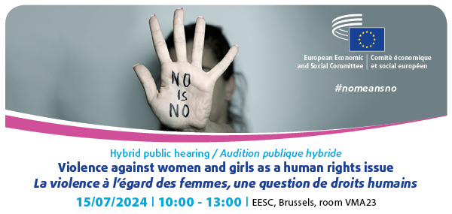

PROGRAMME

The European Economic and Social Committee (EESC) is organizing a hybrid public hearing on "Violence against women as a human rights issue" on 15 July from 10:00-13:00 in order to gather insights from civil society and institutions that could contribute to the preparation of the own-initiative opinion on Violence against women as a human rights issue- State of play of measures across the EU (SOC/798).

Violence against women is the ultimate expression of discrimination against women. It represents a control mechanism that stems from inequality between women and men while at the same time reinforcing and perpetuating this inequality. Not only does this undermine equal coexistence between men and women, it also constitutes an attack on the values and principles enshrined in Article 2 of the Treaty on European Union (TEU). In the 2023 State of the Union address, Commission President Ursula Von der Leyen stressed that "there can be no true equality without freedom from violence".

Despite a good number of EU initiatives on which the EESC gave its contributions concerning gender equality in general (notably the EU Gender Equality Strategy 2020-2025) and the Directive on combating violence against women and domestic violence, the final adopted text of that Directive as adopted by the European Parliament and the Council falls short of full potential.

Therefore, the EESC Fundamental Rights and the Rule of Law (FRRL) Group has decided to propose an Own-Initiative Opinion to examine shortcomings identified in the Directive on combating violence against women and domestic violence.

The hearing will gather stakeholders from civil society and institutions to look into various forms of violence against women and girls that are not covered by the aforementioned Directive. The objective will be to provide a perspective that truly contemplates a common comprehensive policy against gender-based violence, offering a comprehensive and effective strategy against this violation of human rights within the framework of the Union.

09.30 a.m. - 10.00 a.m. | Testing possibility for the Interactio tool for speakers attending online

10.00 a.m. - 10.10 a.m. | Welcome and introduction

- István KOMORÓCZKI, President of the SOC/798 Study Group

- José Antonio MORENO DÍAZ, EESC Rapporteur

- Dovilė JUODKAITĖ, EESC Co-Rapporteur

10.10 a.m. – 11.25 a.m. | Panel I – Implementing the Directive on violence against women and domestic violence and going beyond

In this session participants will be invited to debate how the implementation of the 2024 Directive on violence against women and domestic violence and the 2024 Amending Directive 2011/36/EU on preventing and combating trafficking in human beings by EU Member States, as well as other EU and international instruments and actions could contribute to protecting all women from all forms of violence, while having a human rights approach.

Moderator: José Antonio MORENO DÍAZ, EESC Rapporteur

- Evin INCIR, Member of the European Parliament, Rapporteur for the EU Directive on violence against women and domestic violence

- Maria MOLLICA, Team leader- Stop violence against women, Gender Equality Unit, European Commission Directorate for Justice and Consumers

- Zsuzsanna FELKAI JANSSEN, Team leader- Trafficking in human beings, Organised Crime & Drugs Unit, European Commission Directorate for Migration and Home affairs

- Ana Peláez Narváez, Chair of the UN Committee on the Elimination of Discrimination against Women (CEDAW)

- Irene Rosales, Senior Policy Advisor , European Women's Lobby

Q&A

11:25am- 11:35am Coffee break

11.35 a.m. - 12.50 p.m. | Panel II – Specific forms of gender-based violence requiring stronger response

This session will focus on various forms of gender-based violence that were not included in the 2024 Directive on violence against women and domestic violence and additional elements (e.g, rape based on lack of consent, sexual harassment at work, forced sterilization, prostitution, sexual exploitation, commercial surrogacy and reproductive exploitation. etc). Participants will be encouraged to discuss avenues for stronger and more coordinated response involving the European Union, Member States, and civil society.

Moderator: Dovilė JUODKAITĖ EESC Co-Rapporteur

- Sara ROCHA, Board Member of the European Council of Autistic People and Vice-chair of the European Disability Forum Women's committee

- Dr. Paulina HAUSER, Lecturer of Social ethics, University of Erfurt

- Sif HOLST, Vice-chair Disabled People’s Organisations Denmark and Chair of the EESC Ah-hoc Group on Equality

- Kristina KRAJNC, My voice, my choice Movement

Q&A

12.50 p.m. - 01.00 p.m. | Closing remarks

- José Antonio MORENO DÍAZ, EESC Rapporteur

- Dovilė JUODKAITĖ, EESC Co-Rapporteur

- István KOMORÓCZKI, President of the Study Group

Interpretation:
Participants may speak in: EN, FR, ES, HR, PL, ET and listen in: EN, FR, ES, HR.

