EN

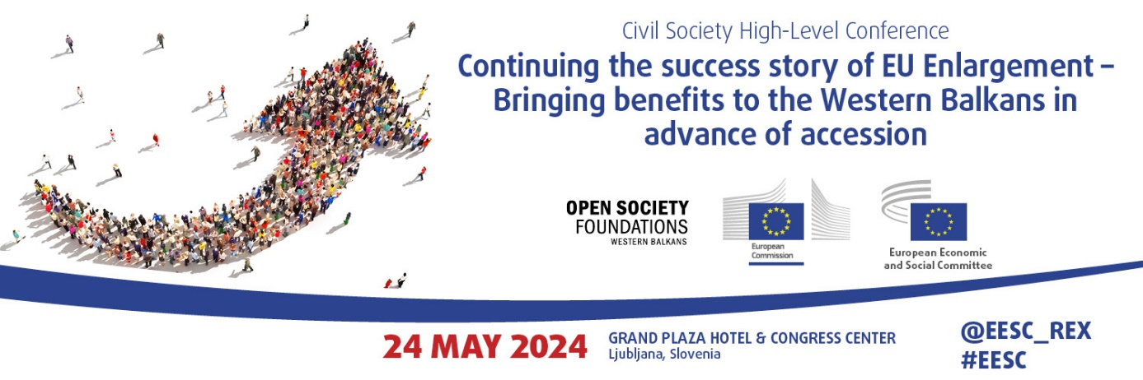

Conclusions of the High-Level Civil Society Conference on Continuing the success story of EU enlargement – Bringing benefits to the Western Balkans in advance of accession - 24 May 2024, Ljubljana, Slovenia

The participants:

- welcomed the renewed commitment to socio-economic convergence and fundamental reforms outlined in the New Growth Plan and the Reform and Growth Facility for the Western Balkans (RGFWB);

- firmly believe that a gradual, predictable and merit-based approach to acquiring increasing benefits during the EU accession process is the best way to proceed towards enlargement of the Union;

- emphasised that the financial pillar of the Growth Plan will be insufficient to make significant impact in the region, and called on the European Commission to substantially increase the amount of the grant component;

- called upon the European Commission to ensure that the beneficiaries are provided with timely technical assistance for acquis alignment and implementation;

- welcomed the robust conditionality approach in the RGFWB, which ties access to increased funding to compliance with payment conditions and measurable progress in implementing reforms, with particular emphasis on democracy, the rule of law and human rights, including minority rights; pointed out that the effectiveness of this approach relies on the Commission’s assessments being methodical, objective and transparent; in addition, called on the Commission to issue clear and transparent guidance on how to apply the proposed conditionality package;

- reiterated the importance of ensuring that the EU’s focus on stability and geopolitical interests does not come at the expense of the rule of law and democracy;

- called upon the Commission to support candidate and potential candidate countries in evaluating both the advantages and drawbacks of early market integration, identifying those that are adversely affected and implementing customised mitigation measures; also stressed that this will be key to preventing the erosion of public support for EU membership in candidate countries and to facilitating their smooth integration into the EU single market; furthermore called upon the Commission to ensure that, when developing such measures, input from the social partners and civil society is sought in a timely manner and duly considered;

- stressed that it is very important to provide direct support to companies from the Western Balkans, both financial and technical, to assist them in obtaining the certificates and documents required to export to the EU;

- called for the elimination or simplification of work permit procedures for individuals from the Western Balkans seeking employment in the EU;

- emphasised the need to align the RGFWB mechanism with EU cohesion policy principles and governance rules, promoting territorial and social development, in order to prepare Western Balkans institutions for when they have full access to cohesion policy funding; also emphasised the importance of aligning support for candidate countries with Member States’ financial instruments for a seamless transition to membership; noted that, going forward, procedures for the use of pre-accession financial instruments should be streamlined in order to avoid creating administrative bottlenecks;

- called upon the Commission to reinforce the gradual integration approach by preparing a proposal to facilitate the candidates’ institutional connectivity and access to the work of the EU institutions, including the Commission’s various directorates-general, even during the accession process, with the aim of stimulating peer learning, gradually building up candidate countries’ administrative capacities, and acclimatising them to EU policy-making and legislative processes;

- called on the Commission to start assessing progress and membership readiness in the ‘Functioning of democratic institutions’ sub-area of Cluster 1 in its regular reports, in a transparent, inclusive, consistent and objective manner, as this area forms a key precondition for EU assistance through the RGFWB; believe that final impact indicators and related milestones regarding all reforms outlined in the Reform Agendas should be set in the subsequent binding agreements;

- considered that investment in social, economic and territorial cohesion is necessary to achieve economic growth and create jobs in the region; recommended that the Commission also prioritise the inclusion of human capital-related reforms and investments in the Reform Agendas, in order to address the limited proportion of such investments supported under the Economic and Investment Plan; also recommended setting social and development-based outcome indicators for all measures included in the Reform Agendas;

- recommended that the implementation of the New Growth Plan be closely followed by measures aimed at developing national administrative capacities as well as those of the social and economic partners, which are crucial for improving the quality of social and civic dialogue in candidate countries;

- in line with the EU partnership principle and the social and economic objectives of the Plan, insisted that the social partners and civil society must be supported in being actively involved in developing, implementing, monitoring and evaluating the Reform Agendas in a timely and meaningful manner; regretted that the social partners were so far only informed of, but not involved in, the development of the Reform Agendas in the Western Balkans; underlines that the Reform Agendas and subsequent binding agreements must include a summary of the relevant mechanisms for engaging the social partners and civil society, and of the consultation process and respective indicators outlining how the input of stakeholders was taken into account; and recommends that the subsequent binding agreements include an outline of the relevant mechanisms for engaging the social partners and civil society, together with respective indicators.

- based on the experience with implementing the Recovery and Resilience Facility (RRF) in the EU Member States, recommended establishing country monitoring committees aimed at enhancing the Plan’s implementation, coordination and monitoring, noting that such committees should include the social partners, as well as specialised civil society organisations (CSOs) from the beneficiary countries;

- considering that at least half of the funds from the RGFWB would be channelled through the Western Balkans Investment Framework (WBIF), reiterated the need for meaningful and timely involvement of specialised CSOs in RGFWB governance, and stressed the importance of including them in the WBIF and in the beneficiaries’ National Investment Committees;

- urged the Commission to make Reform Agendas, subsequent agreements and relevant reports publicly available in a timely manner; furthermore, with a view to enhancing transparency and societal ownership in the region and promoting regular dialogue and public oversight in the Plan’s implementation, welcomed the endorsement of the EESC proposal to establish a scoreboard for the RGFWB based on the Recovery and Resilience Scoreboard in the EU and its adoption by the Council, and look forward to its establishment by making it a key transparency and inclusivity tool;

- called for public and timely availability of all key RGFWB documents and assessment reports, as well as dedicated websites in local languages for Western Balkans Scoreboards, in order to facilitate civil society participation and monitoring;

- stressed the importance of regional cooperation and good neighbourly relations throughout the EU accession process, and welcomed the focus in the Commission’s proposal on developing the Common Regional Market; however, proposed establishing an objective and transparent monitoring system for implementing commitments, with the involvement of the social partners and CSOs and the political will to apply reversibility mechanisms when needed;

- called for intensified diplomatic efforts to resolve the ongoing political disputes in the region, as without normalisation of relations between partners in the Western Balkans, attempts to enhance regional cooperation will likely prove to be challenging;

- welcomed the adoption by the European Parliament of the legislative resolution on the establishment of the Reform and Growth Facility for the Western Balkans on 24 April 2024 and proposed amendments to the original proposal by the European Commission that are in line with the requests from organised civil society; also welcomed the final green light for the RGFWB given by the Council on 7 May 2024.

_____________

